**Toquo English**

**Goal**:

To create a website & app for learners of English to consume fun eLearning videos.

**Specification**

An app for learners of English to consume eLearning instructional videos, and do various learning exercises, do tests and to keep the experience continuously engaging, they should be given the option to chat to other learners to practise their English.

**Functional Requirements**

So that development is given the correct prioritisation I have defined the core functionality separately and optional functionality to be developed later.

**Core features**

*(Defined in this case as being the minimum functionality required to consume video elearning & introduce the site/product)*

Learning Videos

Registration

Login

Demo video

Pitch intro text and images

Pricing table

**Optional Functionality**

Chat box

Level test

Test results

Unit layout structure

Completed units/levels (profile)

Unit Tests

Like and share buttons after exercises.

Comments

After 15 months all of the features were developed on the site.

**User story map**

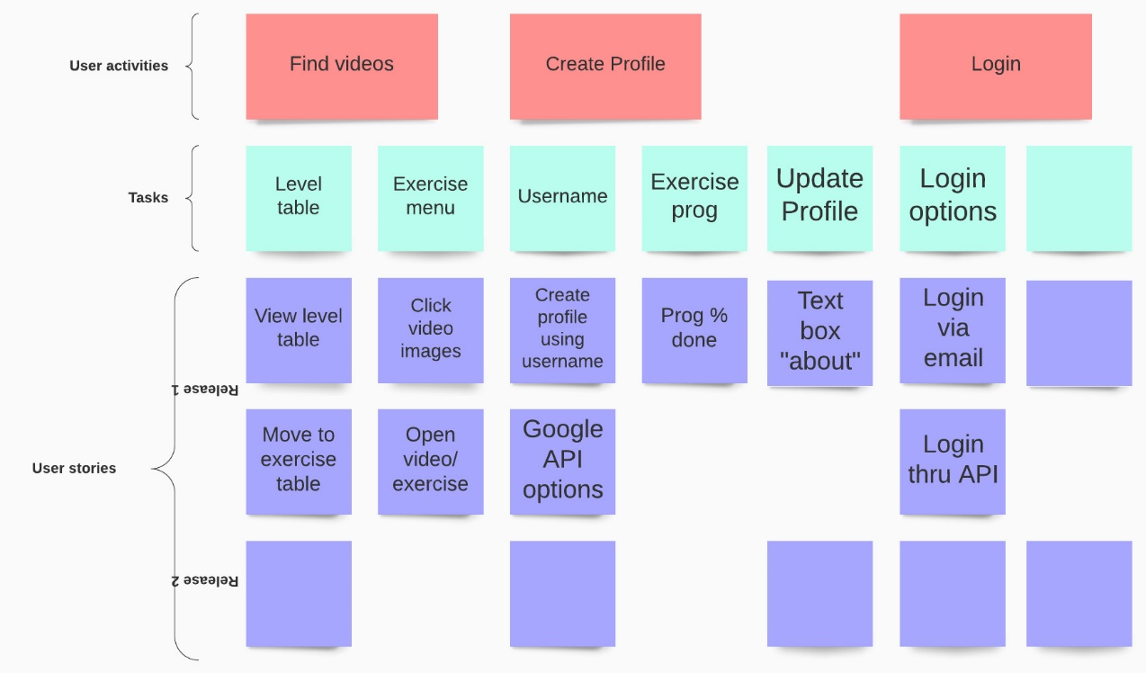

**Wireframes/Prototypes**

App main exercise nav menu.

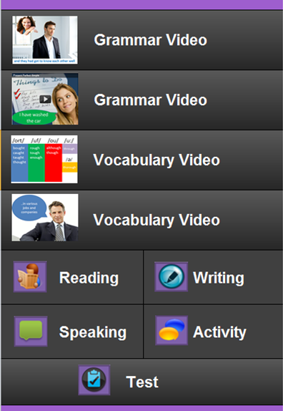

**User stories/PBIs**

Find exercises

Users would like to find specific level exercises through using a level table menu, to allow them to learn from the appropriate level.

Users need to be given a selection of exercises for their chosen level via a main exercise nav menu.

Users would like to navigate from the exercise menu to the video or exercise page.

Users need to be able to watch a video and pause or replay it.

Users must be given a link from video or exercise pages to return to the exercise menu.

Create Profile

Users would like to create profiles, to allow them to use full functionality

Users could be given the option to login via their Google profile.

Users need to be given the option to login via their email or username.

**User Flow**  
 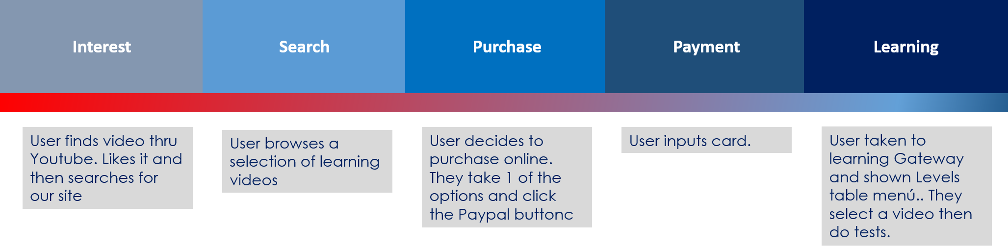

**Persona**

**Learnings**